

Nigel – Assembly Guide

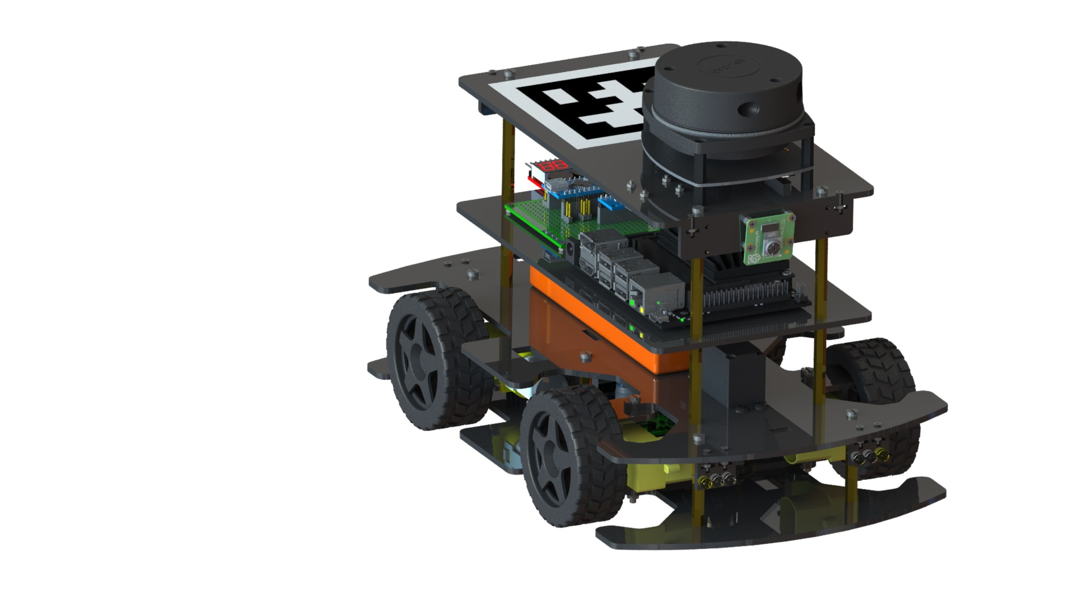

|  |  |
| --- | --- |
| **Drafted By:** | Rohit Ravikumar |
| **Finalized By:** | Tanmay Samak |
| **Version No:** | 1.0.0 |

**Table of Contents**

**1. Introduction** 1

**2. Assembly Guide** 2

**2.1 Platform 1 Assembly** 3

**2.2 Platform 2 Assembly** 11

**2.3 Platform 3 Assembly** 17

**2.4 Platform 4 Assembly** 22

**2.5 Overall Assembly** 27

**3. Modularity and Reconfigurability** 33

**4. Supplemental Material** 34

# **1. Introduction**

The designed vehicle, Nigel, comprises of four modular platforms, each housing distinct components and subsystems of the vehicle. The individual platforms are fabricated by laser cutting 3 mm thick acrylic sheets, which are stacked at the designed offsets employing brass spacers of appropriate length.

The first (i.e., bottom-most) platform hosts the steering mechanism along with power electronics components including a master switch, buck converter, and motor driver with inbuilt electrical braking functionality. The second platform mounts a servo actuator coupled with the steering mechanism on first platform, along with front and rear lighting units. It also has a provision for strapping a lithium polymer (LiPo) battery. Two DC geared motors driving the rear wheels and two free gearboxes coupled with the front wheels are fastened to their respective acrylic mounts fixed between the first and second platforms. The third platform accommodates an onboard computer, along with a custom auxiliary board and LiPo voltage checker. The auxiliary board routes connections to the low-level microcontroller unit and takes care of power distribution as well. It also hosts a 9-axis IMU. Finally, the fourth platform mounts two CSI cameras and a planar LIDAR unit. It also has vacant space to paste an AprilTag marker to uniquely identify the vehicle. The figure below illustrates various components and sub-systems of the vehicle.

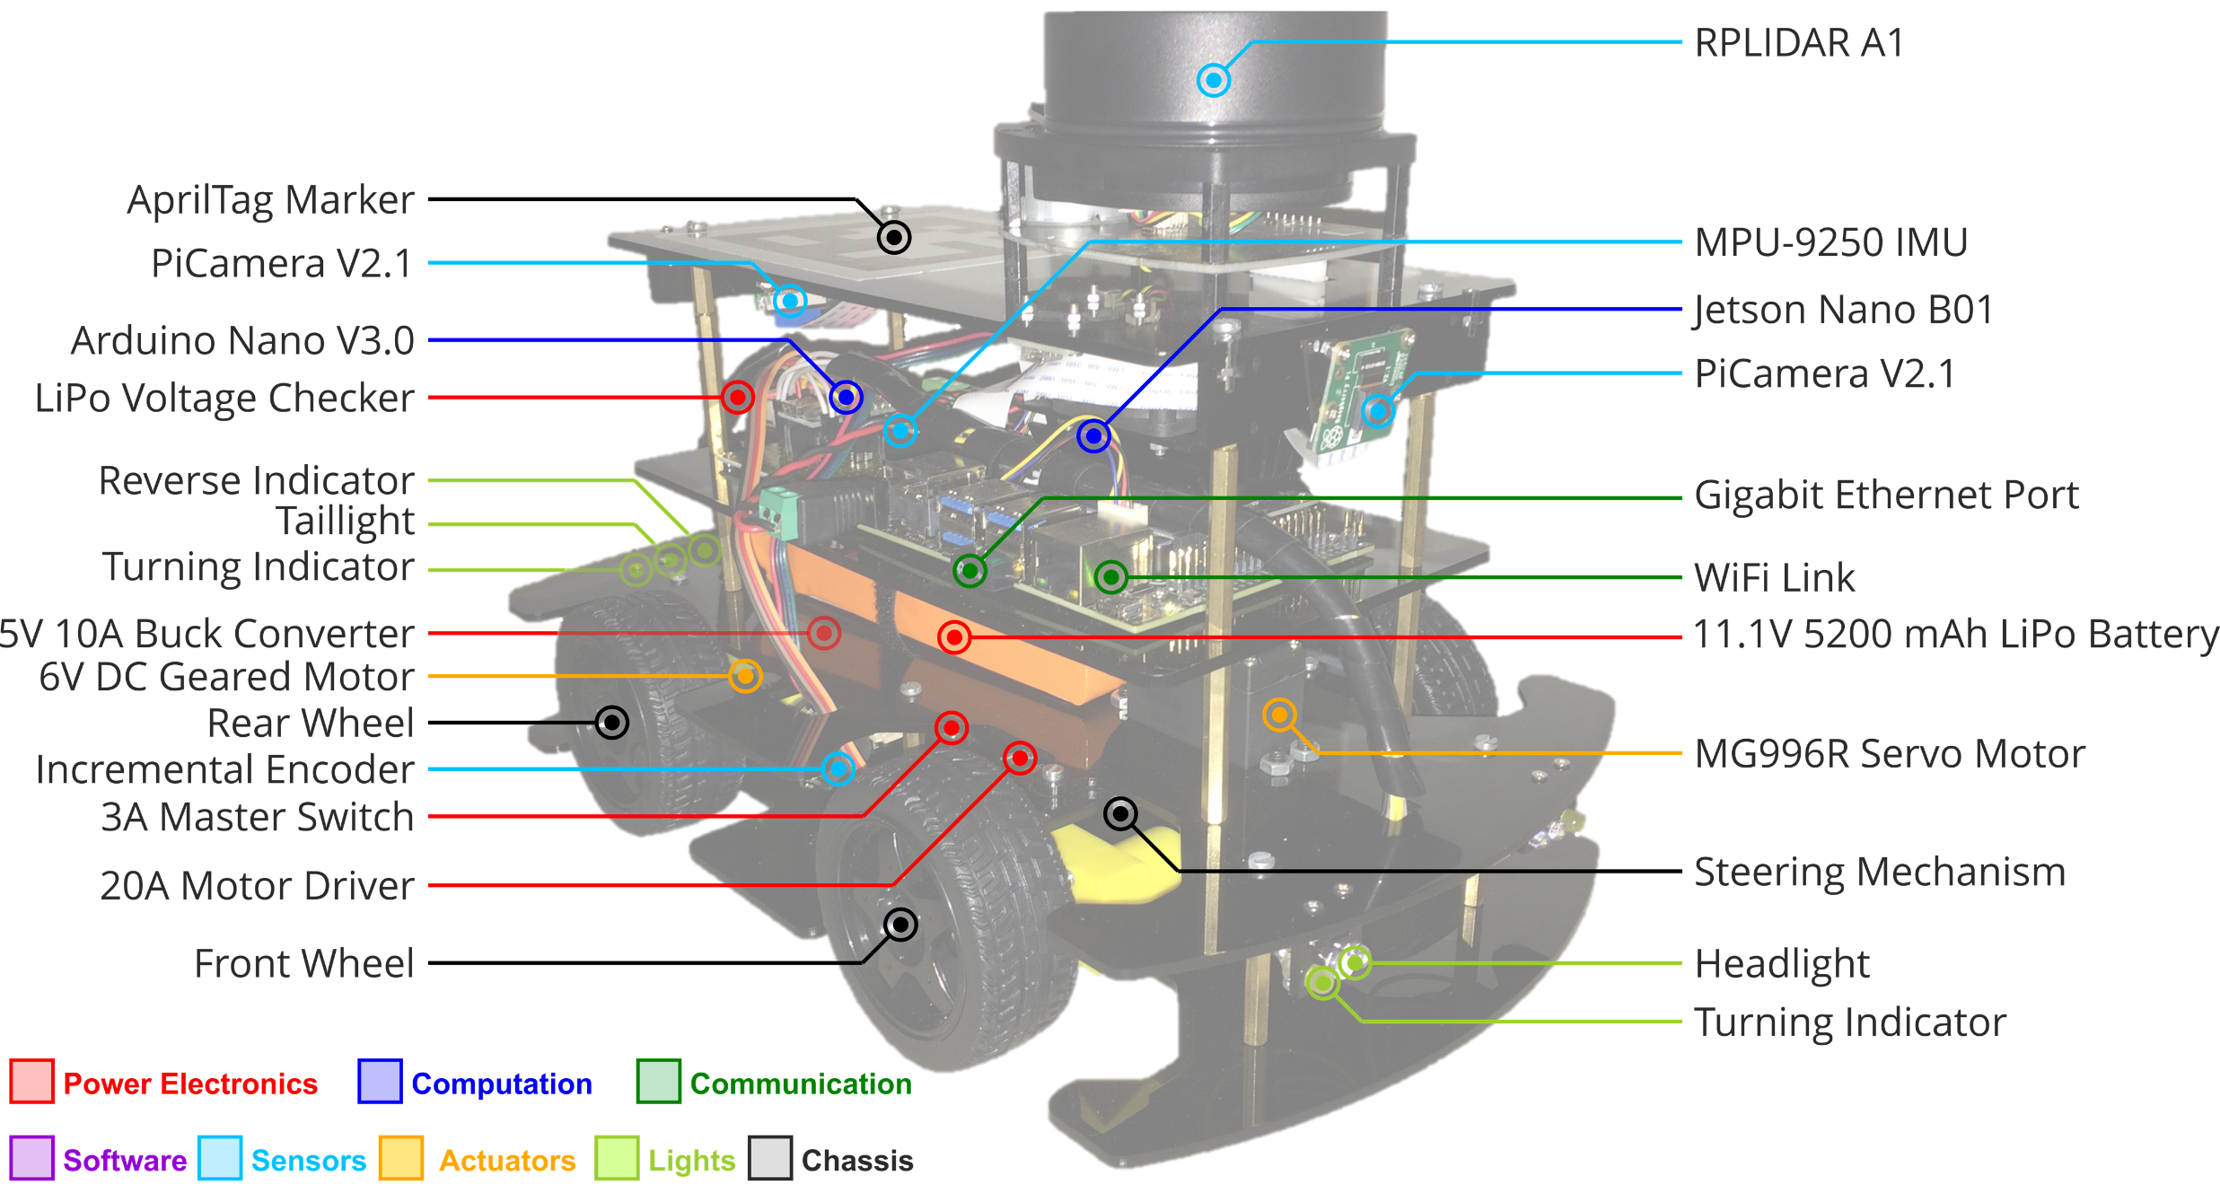

# **2. Assembly Guide**

The entire assembly process can be divided platform-wise. The individual platforms can be assembled as sub-assemblies and then stacked using standoffs to complete the overall assembly.

This manual goes through the entire assembly process in this fashion, with overall steps and detailed instructions on how to assemble each platform.

Detailed bill of materials (BOM) can be found [here](https://github.com/Tinker-Twins/AutoDRIVE/blob/AutoDRIVE-Testbed/Documents/BOM.xlsx).

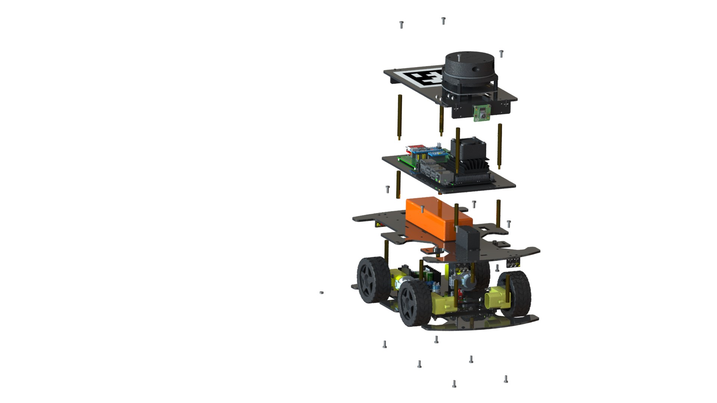

**PLATFORM 2**

**PLATFORM 1**

**PLATFORM 3**

**PLATFORM 4**

## **2.1 Platform 1 Assembly**

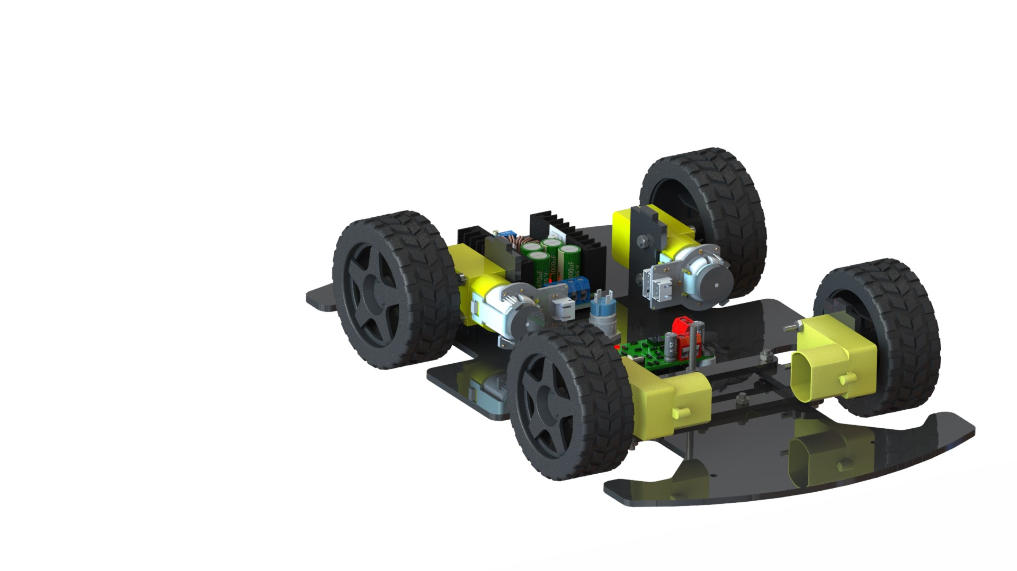

**Components:**

|  |  |  |  |
| --- | --- | --- | --- |
| **Buck Converter (x1)** | **Motor Driver (x1)** | **Push Button (x1)** | **Rear Motor (x2)** |
| **Front Wheel Hub (x2)** | **Platform 1 (x1)** | **Wheel (x4)** | **Front Motor Mount (x2)** |
| **Rear Motor Mount (x2)** | **Steering Knuckle 1 (x2)** | **Steering Link 1 (x1)** | **Steering Link 2 (x1)** |
| **M4 x 5 Spacer (x4)** | **Push Button Nut (x1)** | **M2 x 10 Bolt (x4)** | **M2.5 x 25 Bolt (x4)** |
| **M3 x 10 Bolt (x4)** | **M3 x 14 Bolt (x6)** | **M3 x 25 Bolt (x5)** | **M3 Nut (x15)** |
| **M2.5 Nut (x4)** | **M2 Nut (x4)** |

**Overall Steps:**

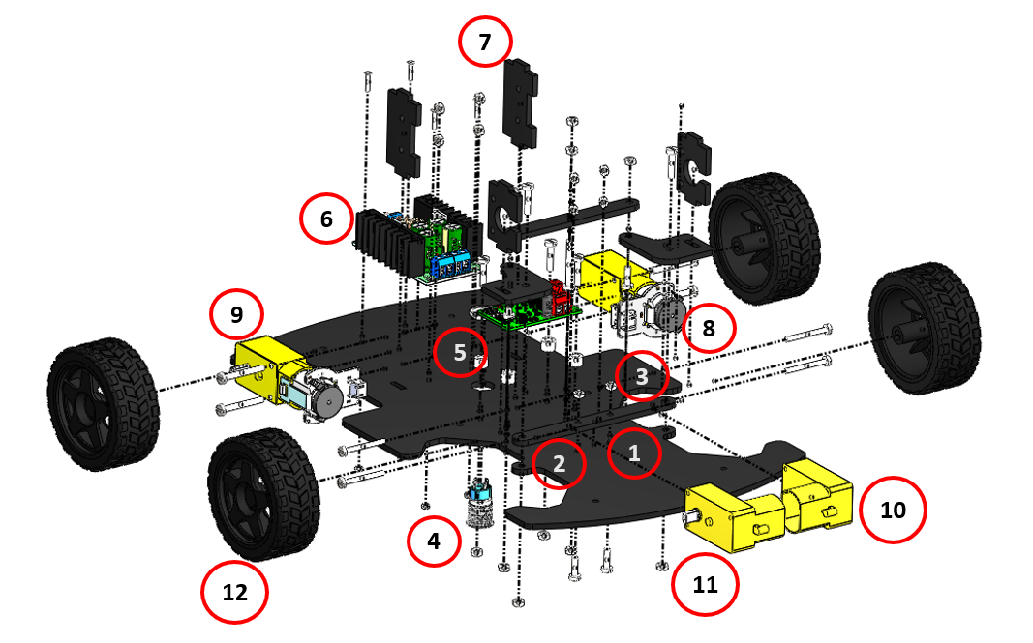

**Detailed Steps:**

1. Assembly of the lower steering linkage.

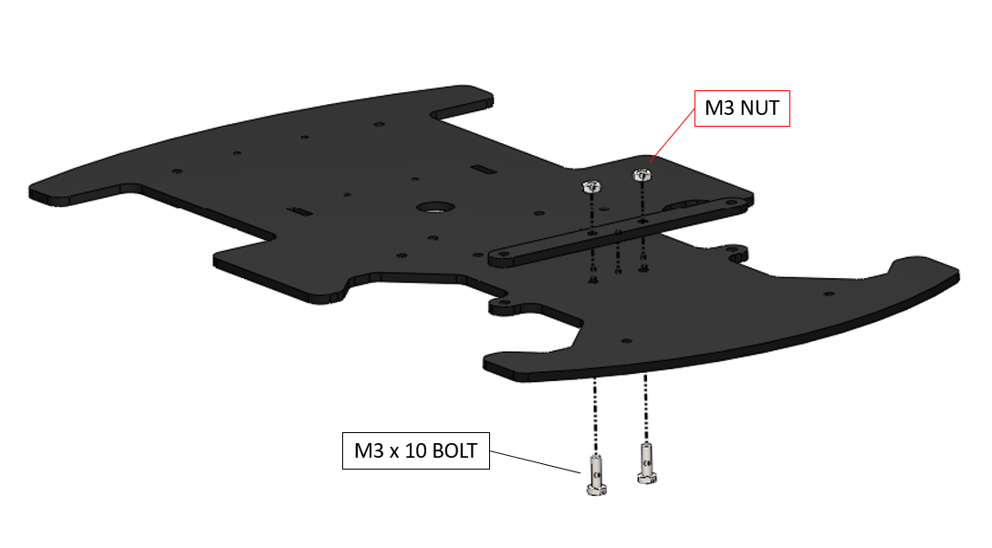

1. Assembly of the upper steering linkage.

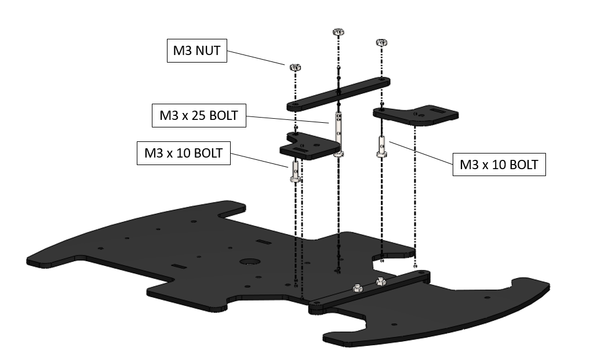

***Note:*** *Once the nuts are inserted in place on the M3 x 10 bolts do not tighten them too much as it is a moveable joint. Hot glue can be added to secure the position of these nuts.*

1. Securing the upper steering linkage onto the lower one.

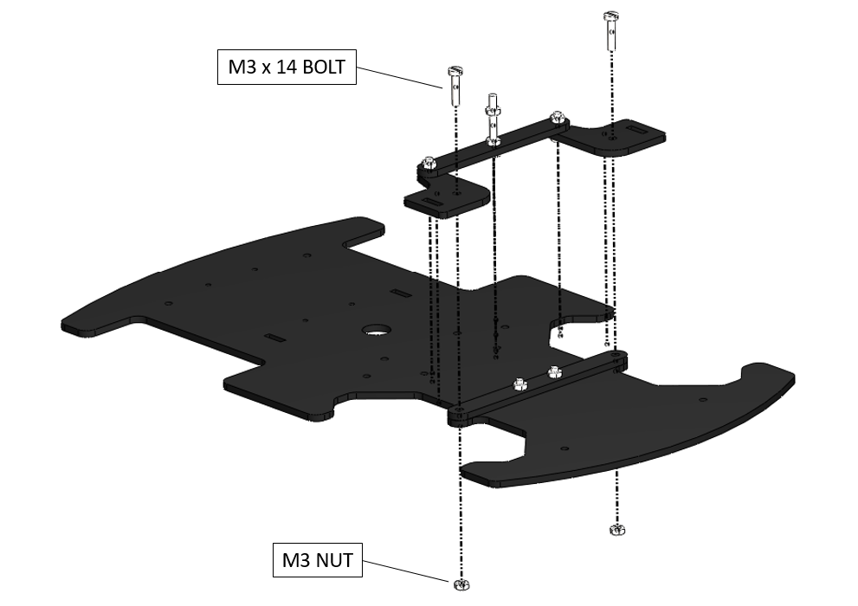

1. Assembly of the master switch onto the platform.

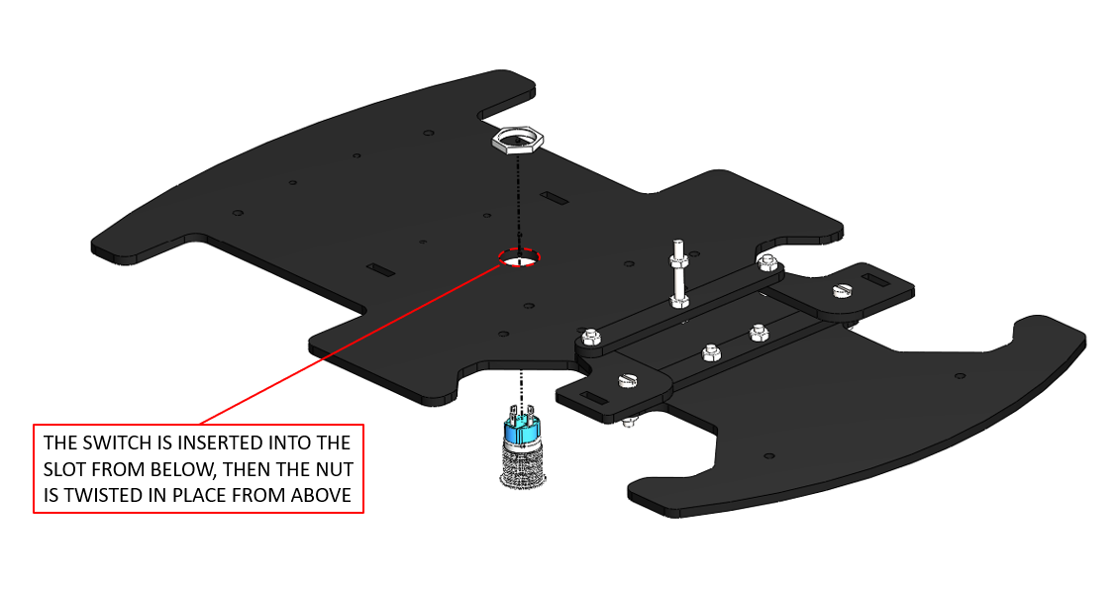

1. Assembly of the motor driver onto the platform.

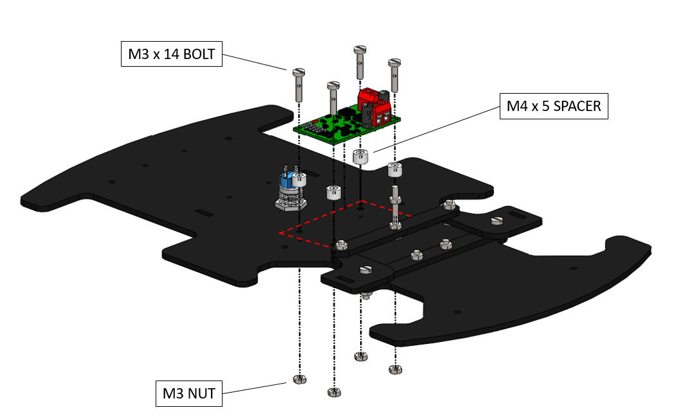

***Hint:*** *You may use M3 nuts as spacers in case you cannot find M4 x 5 spacers. However, make sure that the nuts are not shorting any traces on the PCB.*

***Hint:*** *You may use L298N motor driver in case the one shown here is not available. However, make sure to upgrade the vehicle hardware (Platform 1 mounting points) and firmware to suit the alternative motor driver.*

1. Assembly of the buck converter onto the platform.

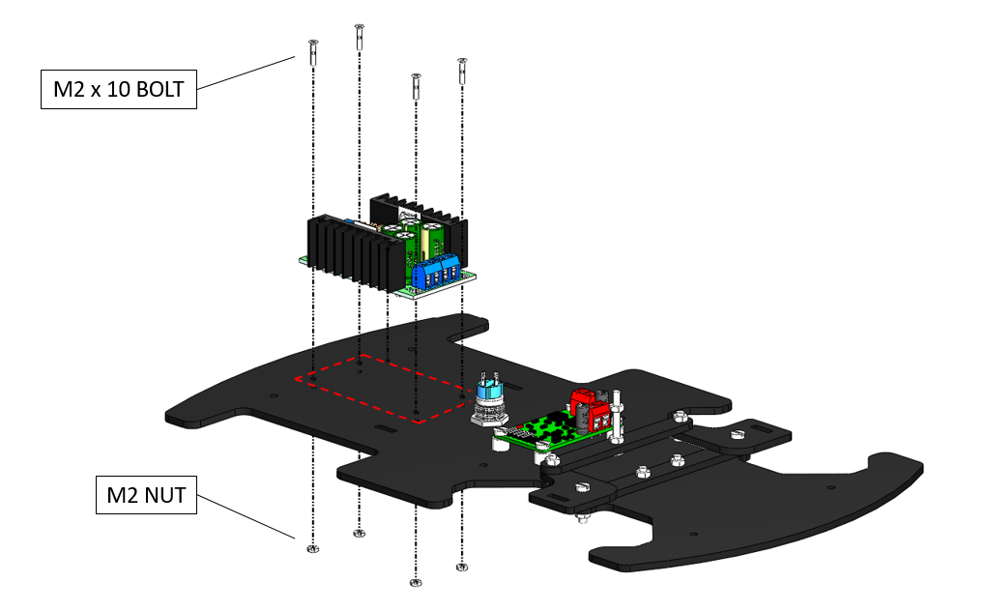

***Note:*** *Make sure to tune the output voltage of the buck converter to 5.00 V.*

1. Assembly of the front and rear motor mounts onto the platform.

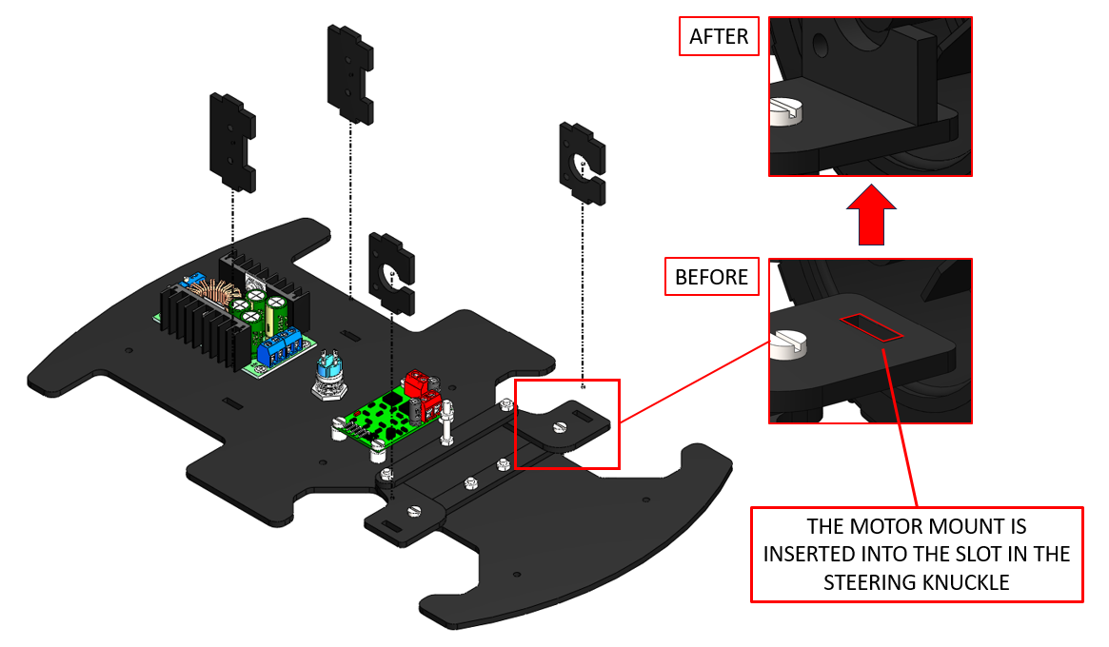

***Hint:*** *Although the motor mounts are designed to friction-fit into the respective slots, the fit might be loose in some cases due to manufacturing errors. In such a case, hot glue can be added to secure them in place.*

1. Fitment of the rear-left motor.

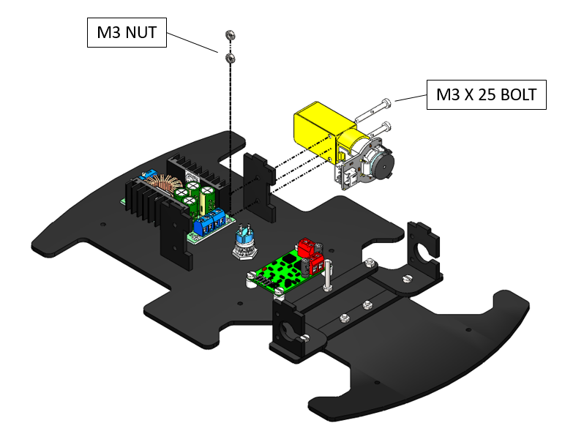

1. Fitment of the rear-right motor.

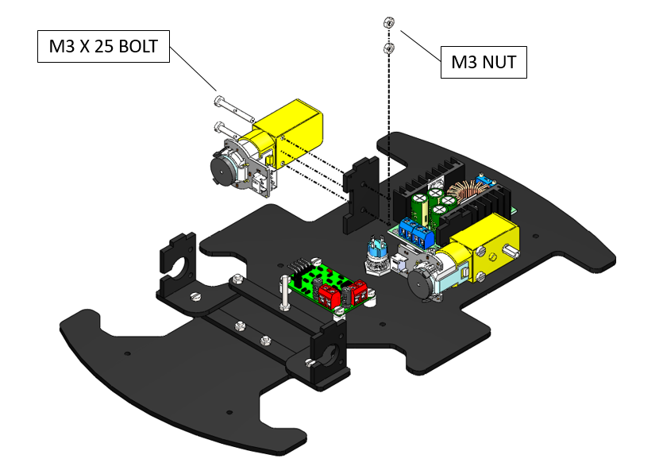

1. Fitment of the front-left wheel hub.

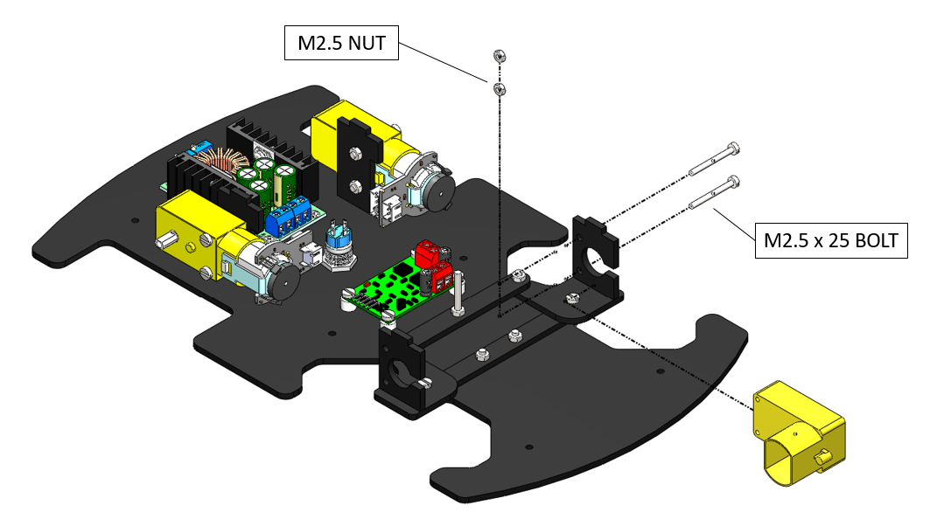

1. Fitment of the front-right wheel hub.

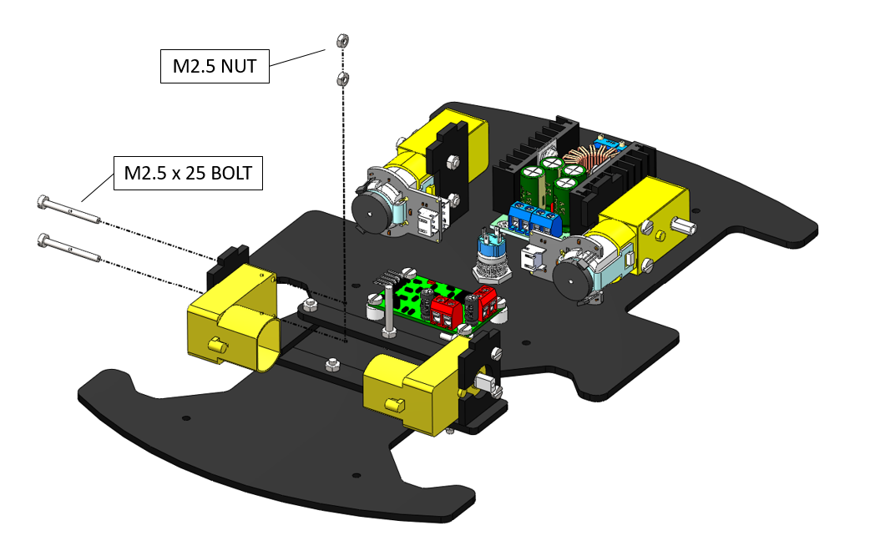

***Hint:*** *You may add motors to the front/rear/all wheels to alter the drive configuration.*

1. Assembly of the wheels.

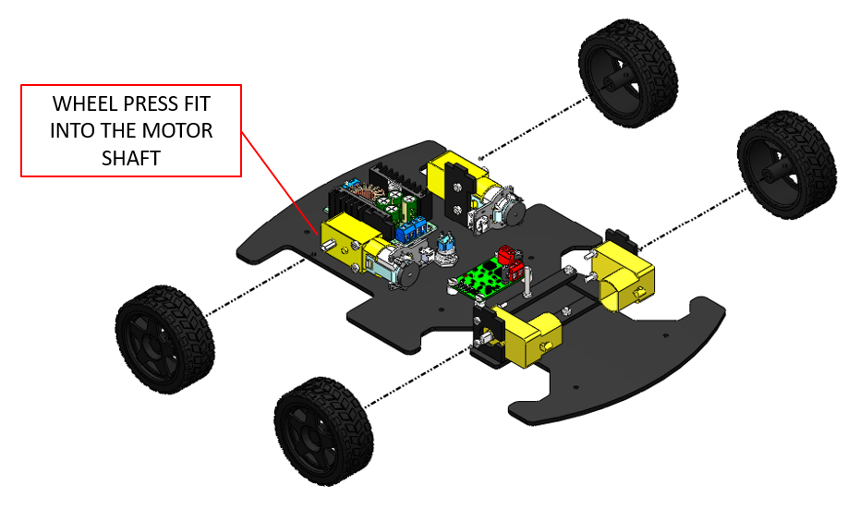

## **2.2 Platform 2 Assembly**

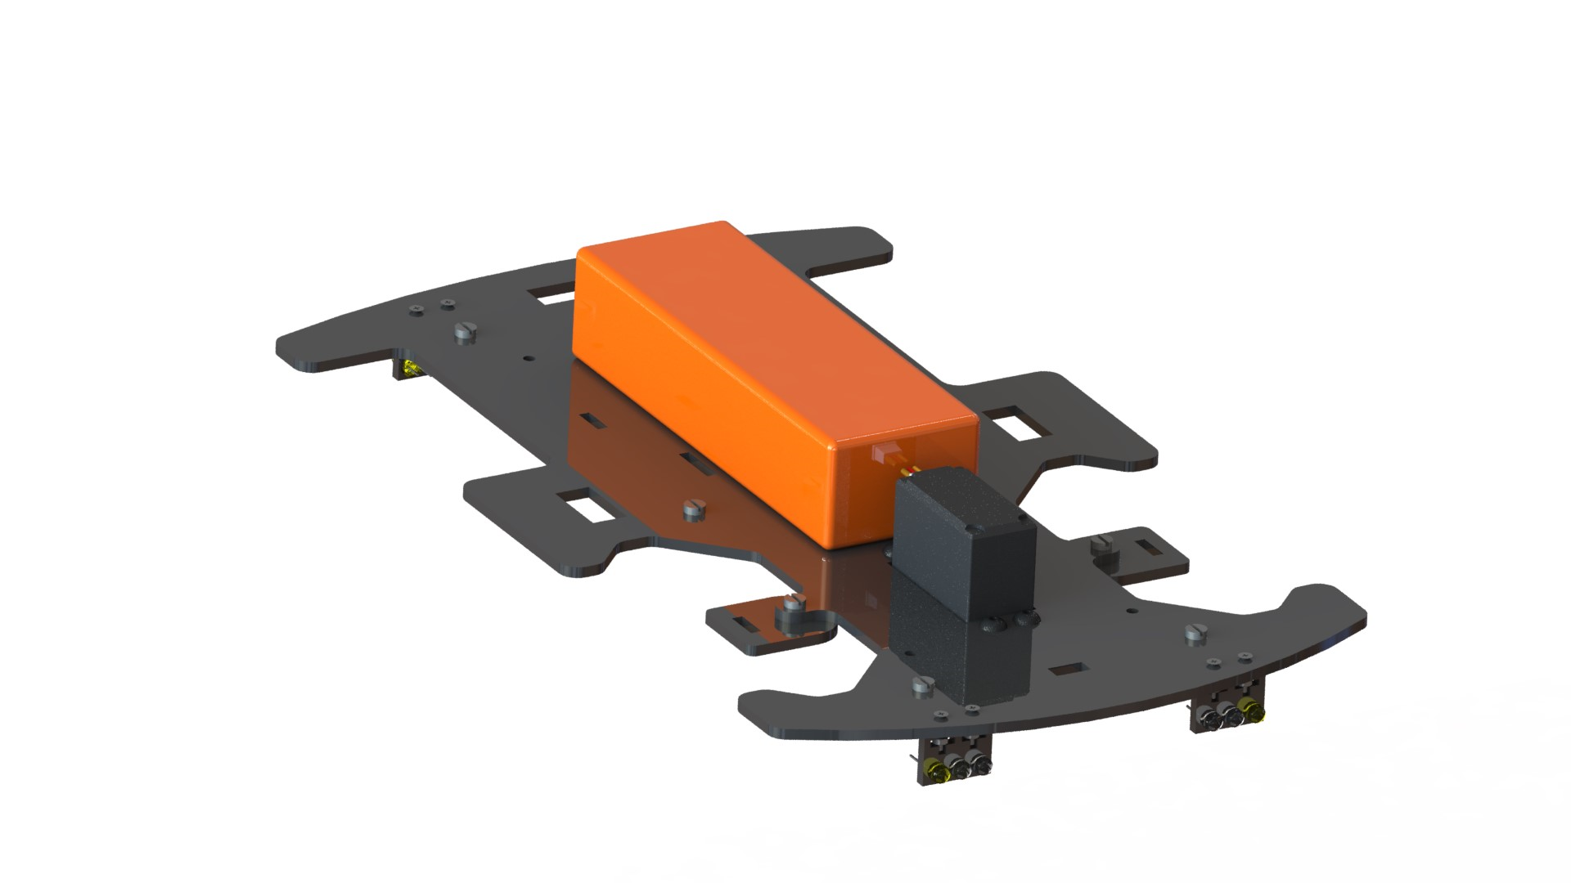

**Components:**

|  |  |  |  |
| --- | --- | --- | --- |
| **11.1V LiPo Battery (x1)** | **MG996R Servo (x1)** | **Amber LED (x4)** | **Red LED (x2)** |
| **White LED (x6)** | **Steering Knuckle (x1)** | **Platform 2 (x1)** | **LED Mount (x4)** |
| **Acrylic Servo Horn (x1)** | **MG996 Servo Horn (x1)** | **M2 x 10 Bolt (x8)** | **M2 Nut (x8)** |
| **M3 x 10 Bolt (x2)** | **M3 Nut (x2)** | **M4 x 10 Bolt (x4)** | **M4 Nut (x4)** |
| **M3 x 6 Bolt (x5)** |

**Overall Steps:**

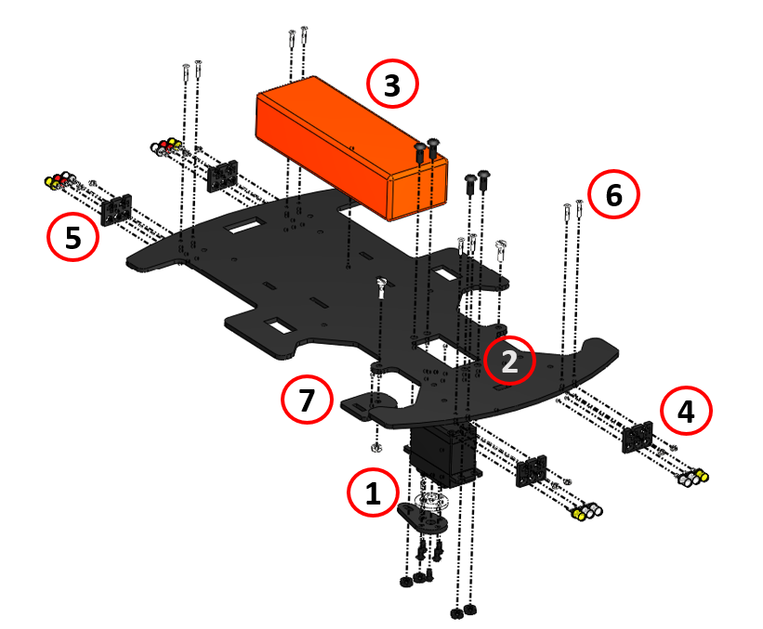

**Detailed Steps:**

1. Assembly of the servo horns onto the servo motor.

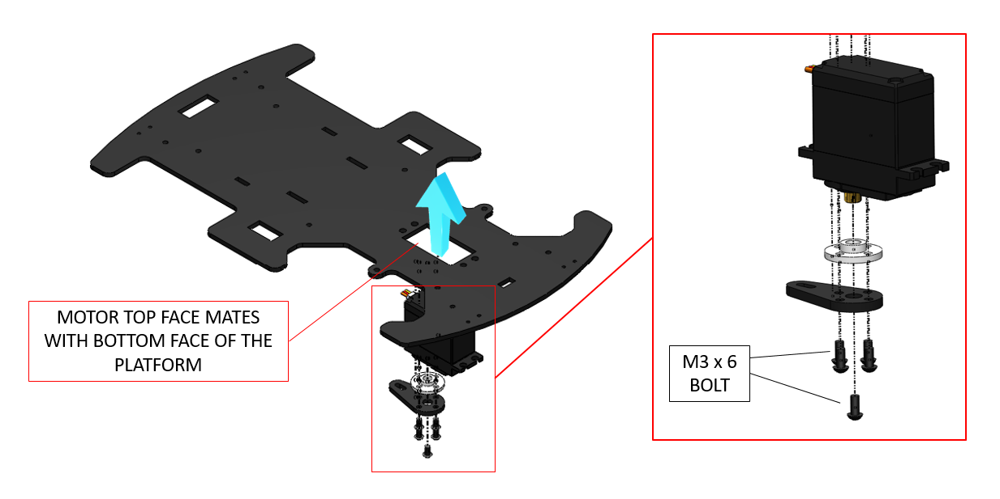

***Note:*** *Make sure to zero-steer the servo to 90 $°$ before attaching the servo horn.*

1. Fitment of the servo motor onto the platform.

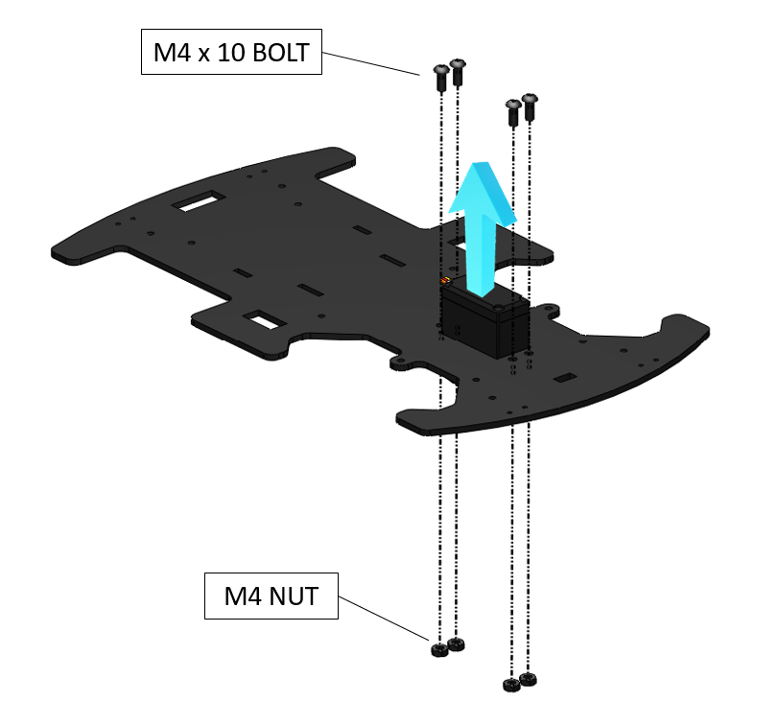

1. Securing the LiPo battery onto the platform.

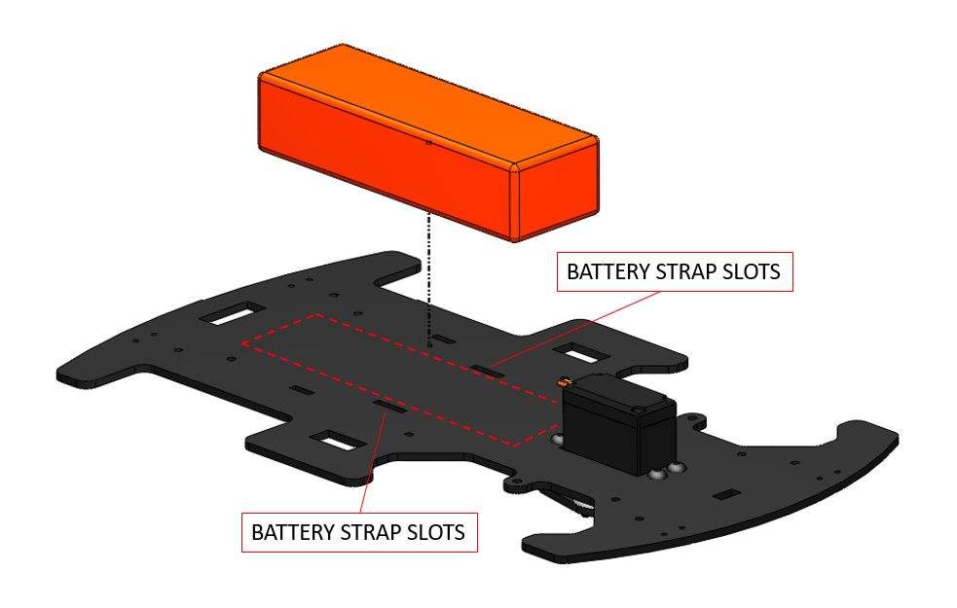

***Note:*** *LiPo batteries are a safety hazard. Please refer to* [*this guide*](https://dronebotworkshop.com/lipo-safety/) *to know more about LiPo safety.*

1. Fitment and sub-assembly of the headlights.

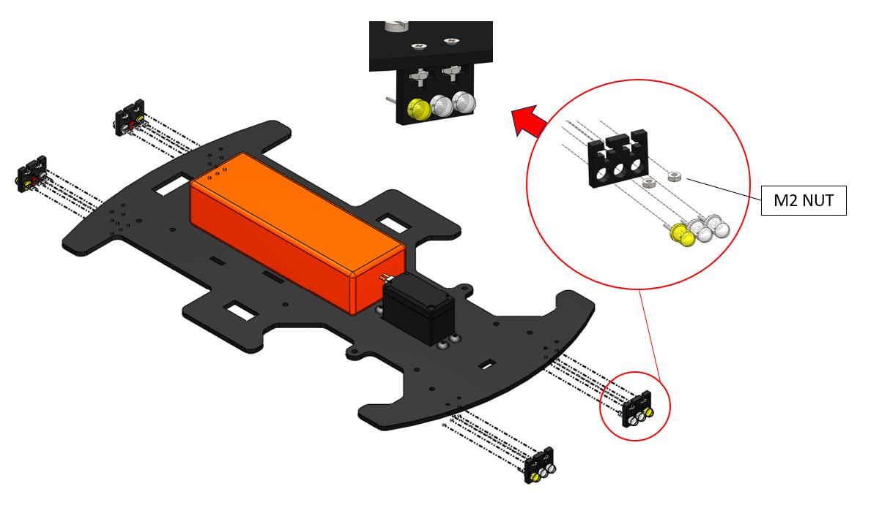

1. Fitment and sub-assembly of the taillights.

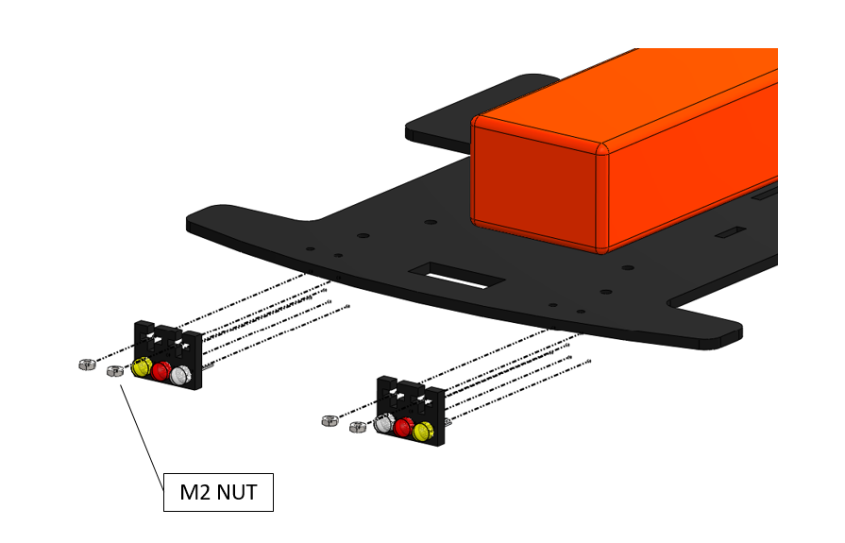

***Hint:*** *Although the LED mounts are designed to friction-fit 5 mm LEDs, the fit might be loose in some cases due to manufacturing errors. In such a case, hot glue can be added to secure the LEDs in place.*

1. Assembly of the headlights and taillights onto the platform.

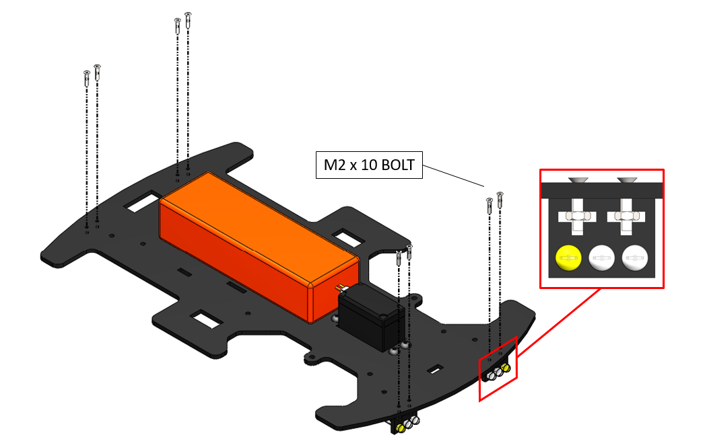

1. Assembly of the upper steering knuckles onto the platform.

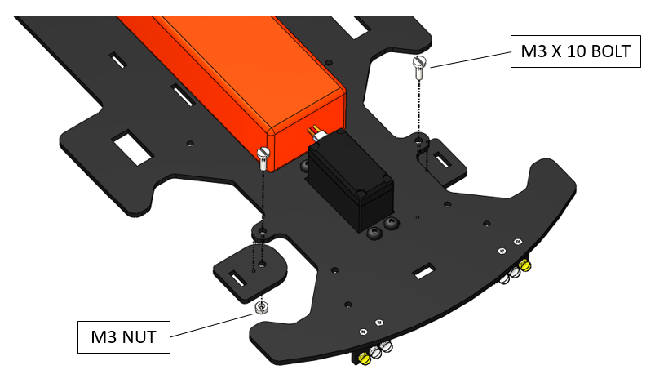

***Note:*** *Once the nuts are inserted in place on the M3 x 10 bolts do not tighten them too much as it is a moveable joint. Hot glue can be added to secure the position of these nuts.*

## **2.3 Platform 3 Assembly**

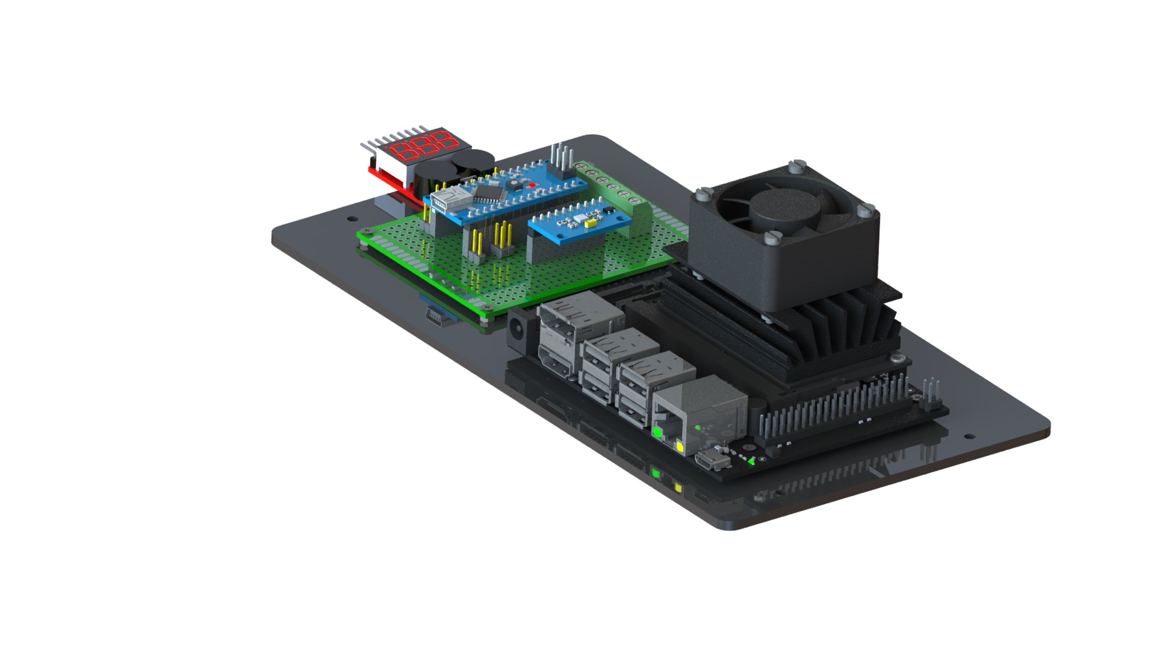

**Components:**

|  |  |  |
| --- | --- | --- |
| **Jetson Nano B01 (x1)** | **Auxiliary Board (x1)** | **LiPo Battery Voltage Checker (x1)** |
| **4020 DC Fan (x1)** | **Platform 3 (x1)** | **M2.5 x 25 Bolt (x4)** |
| **M2 x 10 Bolt (x8)** | **M2.5 Nut (x4)** | **M2 Nut (x12)** |

**Overall Steps:**

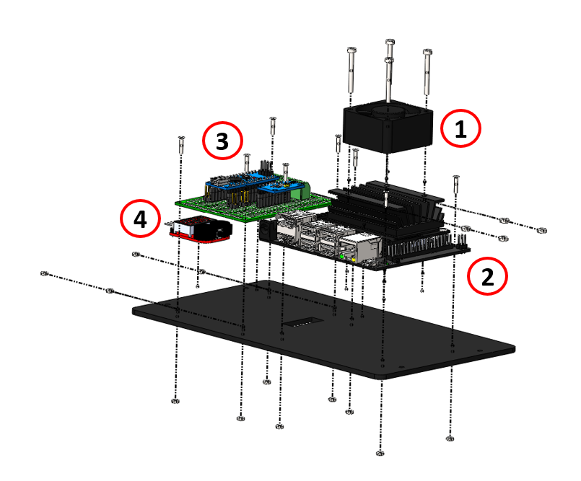

**Detailed Steps:**

1. Fitment of the DC fan onto the heatsink of Jetson Nano.

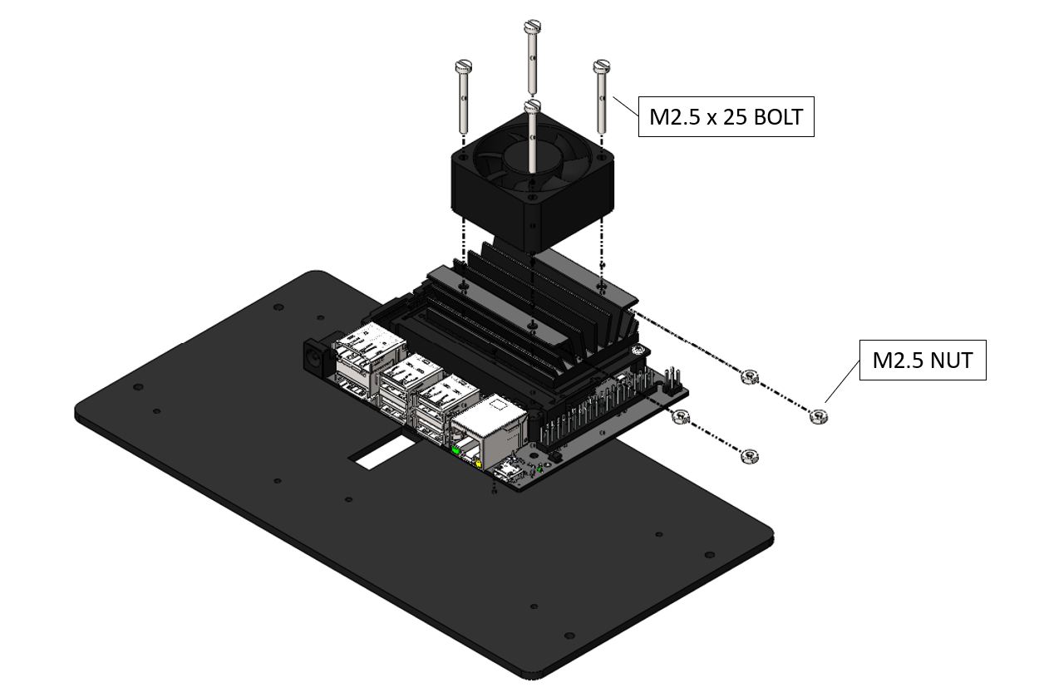

1. Assembly of the Jetson Nano onto the platform.

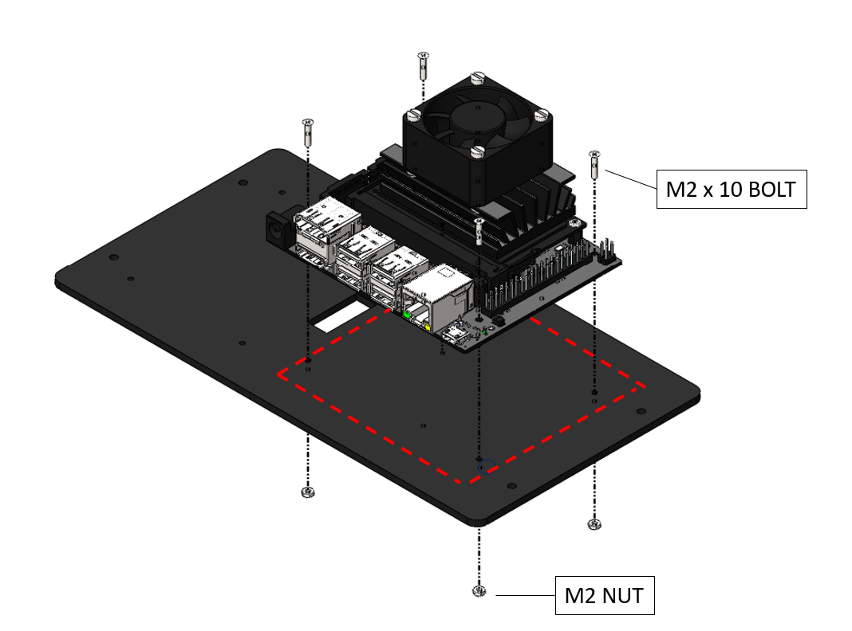

1. Assemble the auxiliary board PCB based on the flowing schematic and layout.

|  |  |  |
| --- | --- | --- |
|  |  |  |
| [Breadboard View](https://github.com/AutoDRIVE-Ecosystem/Nigel-Fritzing/blob/pcb-v1.0.0/Breadboard.png) | [Schematic View](https://github.com/AutoDRIVE-Ecosystem/Nigel-Fritzing/blob/pcb-v1.0.0/Schematic.png) | [PCB View](https://github.com/AutoDRIVE-Ecosystem/Nigel-Fritzing/blob/pcb-v1.0.0/PCB.png) |

***Hint:*** *The hyperlinks will re-direct to high-resolution images for better clarity. Additionally, the open-source PCB designs are available* [*here*](https://github.com/AutoDRIVE-Ecosystem/Nigel-Fritzing/tree/pcb-v1.0.0)*.*

1. Assembly of the auxiliary board onto the platform.

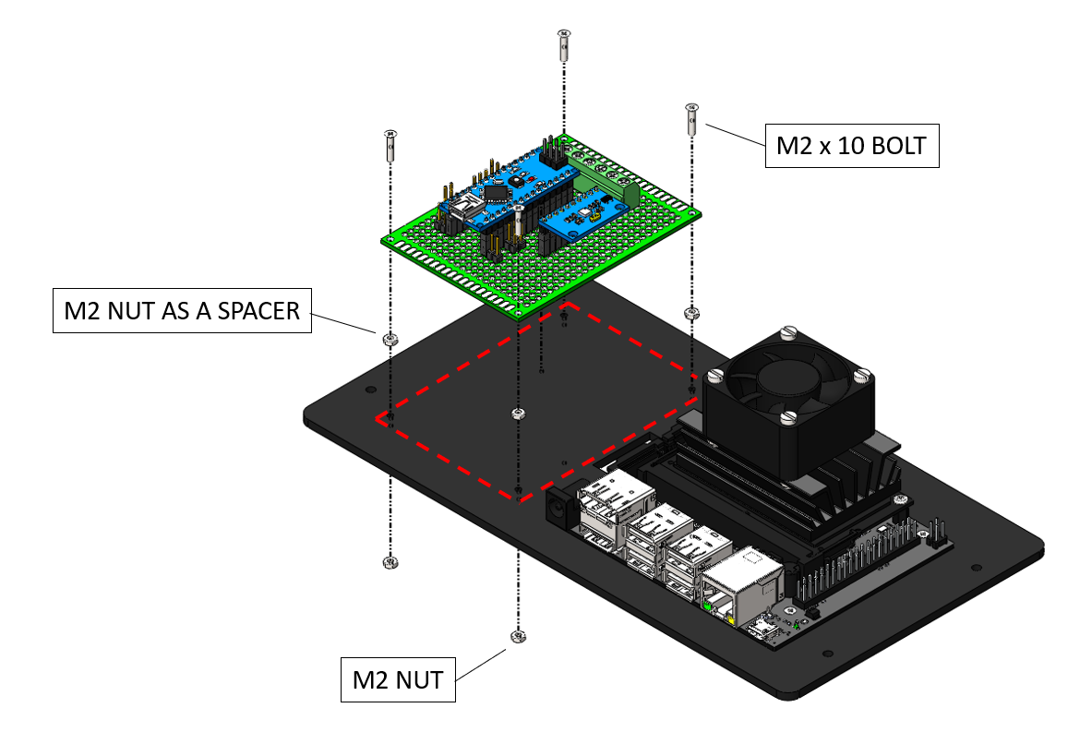

1. Assembly of the voltage checker module onto the platform.

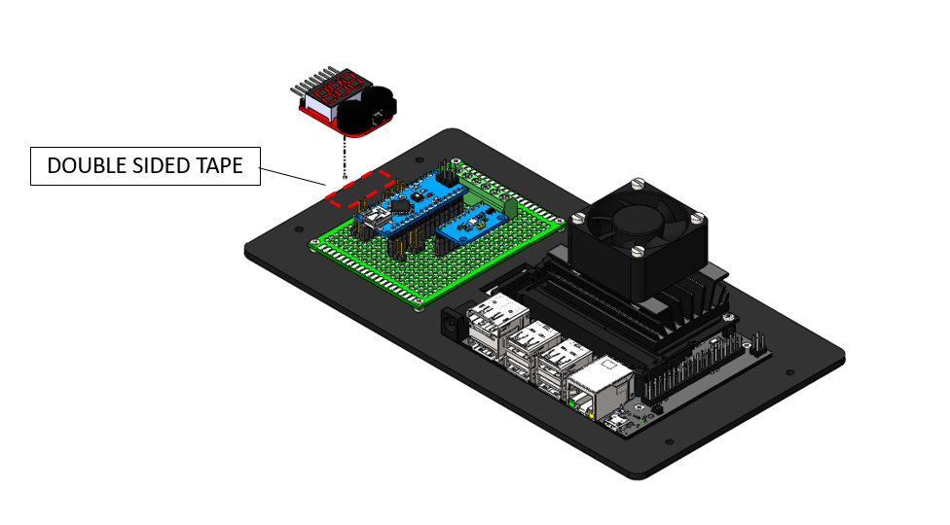

***Hint:*** *You may use hot glue or double-sided tape to secure the voltage checker module in place.*

## **2.4 Platform 4 Assembly**

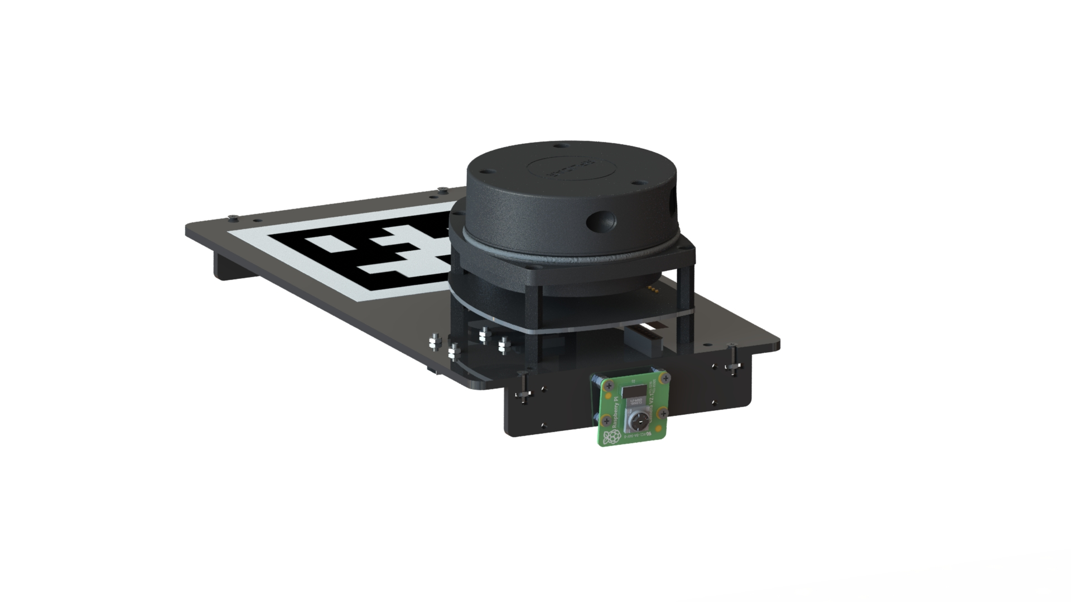

**Components:**

|  |  |  |
| --- | --- | --- |
| **RPLIDAR A1 (x1)** | **LIDAR Adapter (x1)** | **PiCam V2.1 (x2)** |
| **Platform 4 (x2)** | **Camera Mount (x2)** | **AprilTag Marker (x1)** |
| **M2.5x8 Bolt (x4)** | **M2x10 Bolt (x16)** | **M2 Nut (x32)** |

**Overall Steps:**

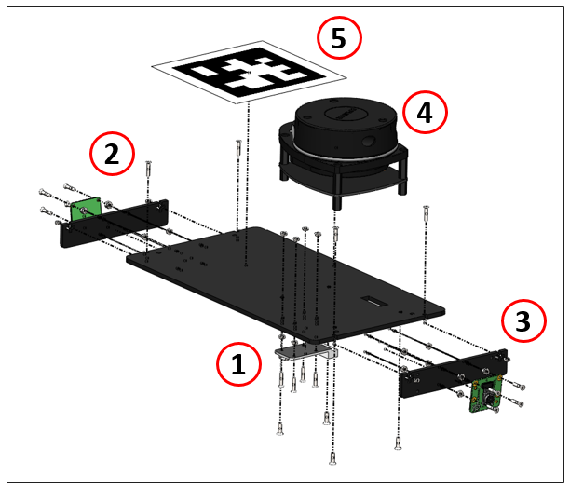

**Detailed Steps:**

1. Fitment of the LIDAR adapter onto the platform.

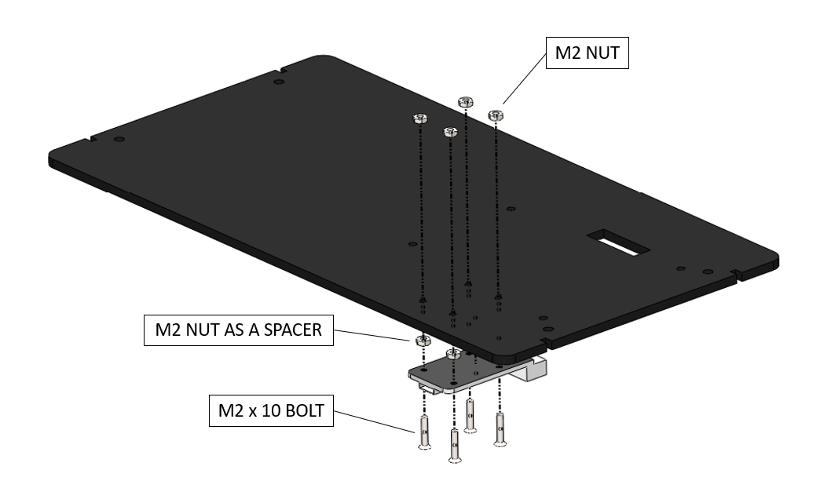

1. Assembly of the rear camera mount onto the platform.

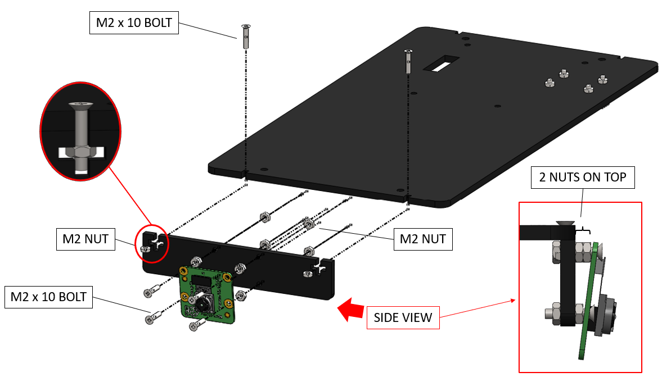

***Hint:*** *You may alter the tilting angle of the front/rear camera(s) by varying the number of spacer nuts in the top and bottom mounting holes.*

1. Assembly of the front camera mount onto the platform.

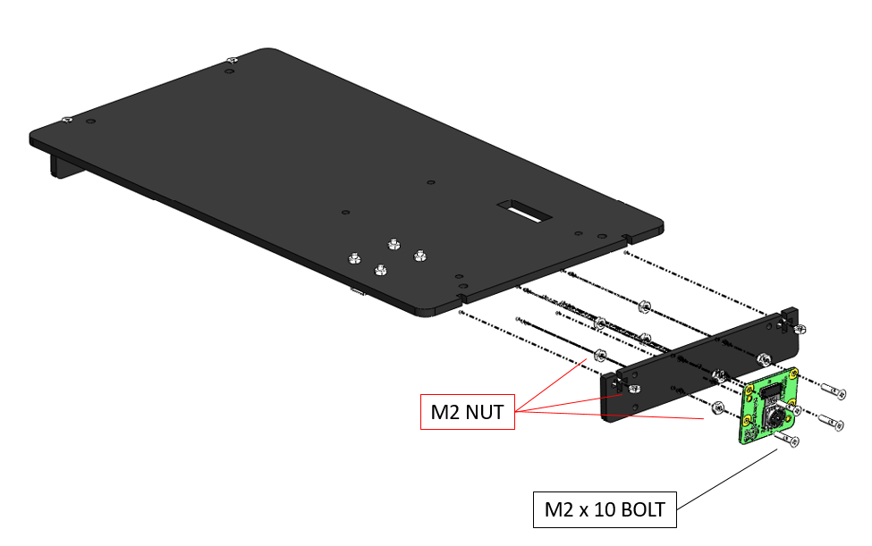

1. Assembly of the LIDAR onto the platform.

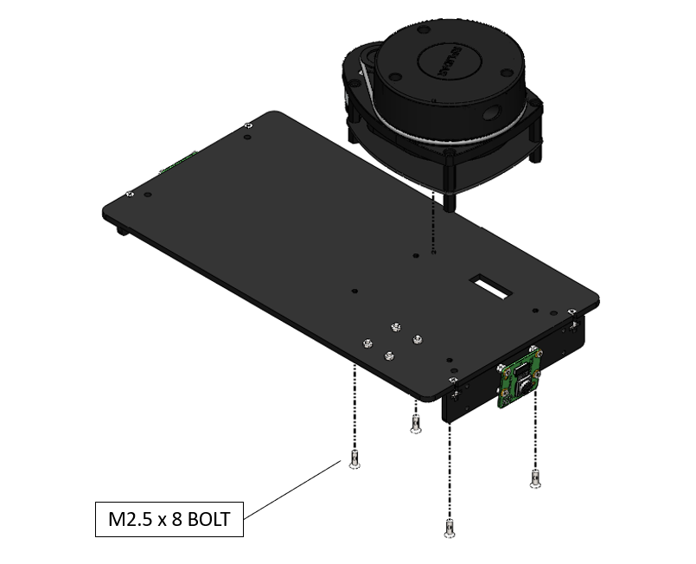

1. Assembly of the AprilTag marker onto the platform.

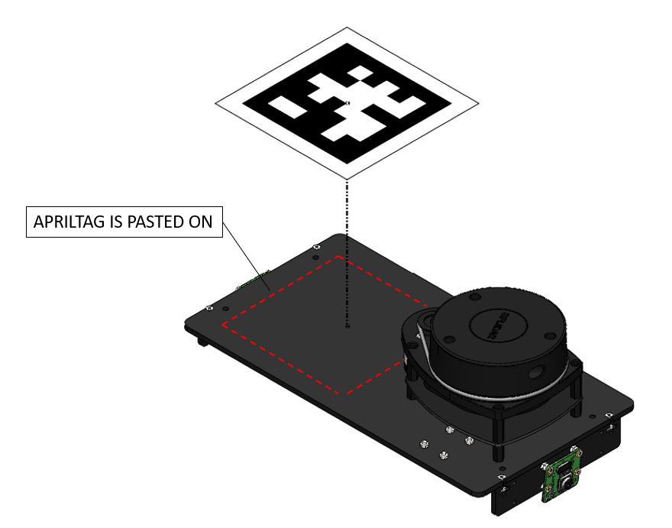

***Hint:*** *In a multi-agent setting, you can use distinct AprilTag markers on each vehicle to uniquely identify them.*

## **2.5 Overall Assembly**



**Components:**

|  |  |  |  |
| --- | --- | --- | --- |
|   **M3 x 60 MF Standoff (x4)** |   **M3 x 40 FF Standoff (x10)** |   **M3 x 8 Bolt (x20)** |   **M3 Nut (x1)** |

**Overall Steps:**

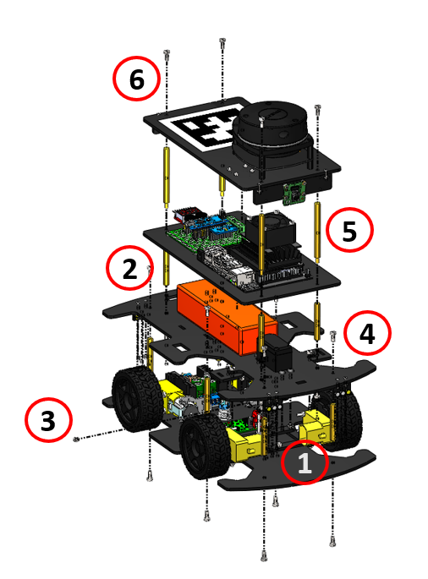

**Detailed Steps:**

1. Assembly of the standoffs on Platform 1.

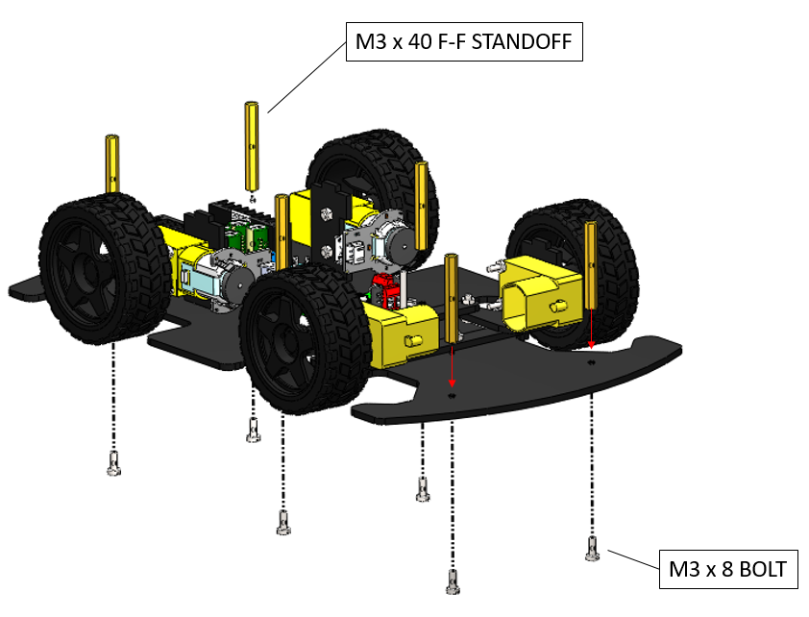

1. Assembly of the standoffs on Platform 2.

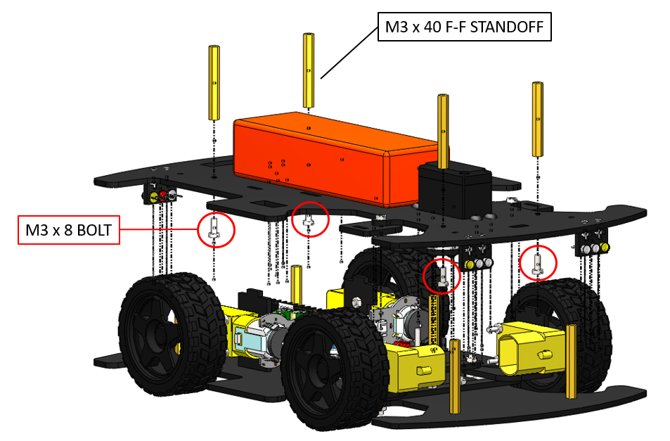

1. Securing the steering mechanism with the nut as shown below. This involves inserting the bolt of the steering system from Platform 1 into the slot of the acrylic horn of the servo motor on Platform 2.

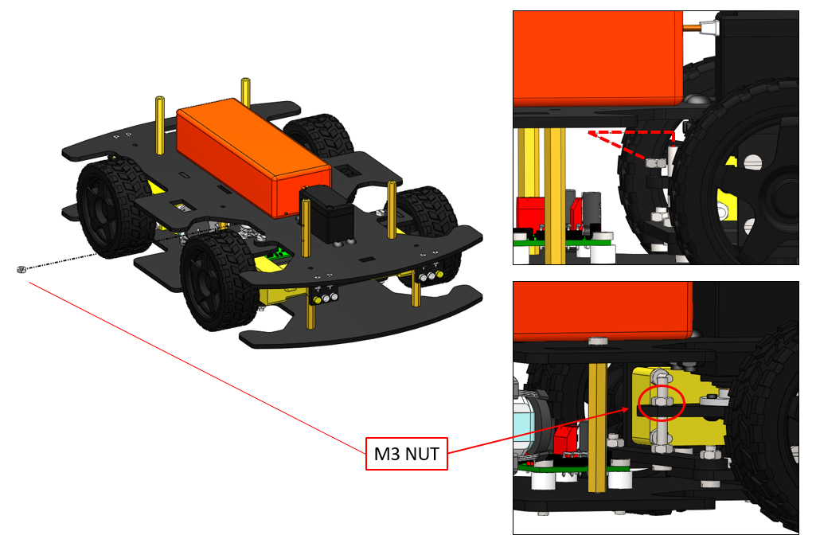

1. Securing the 2nd Platform onto the 1st Platform.

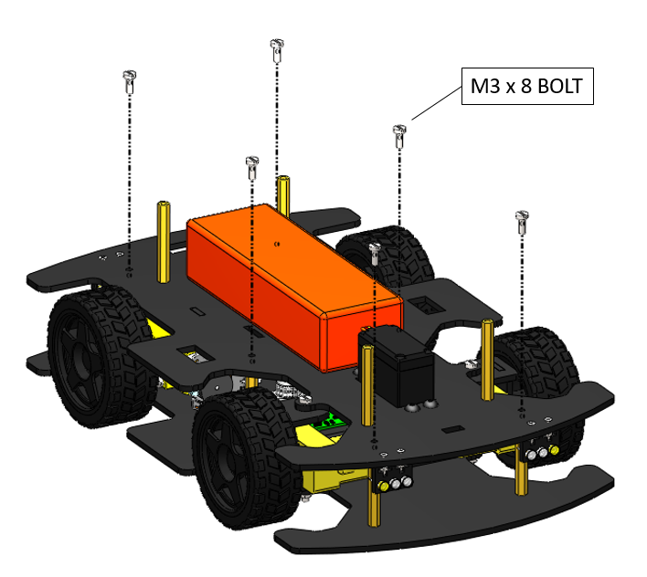

1. Securing the 3rd Platform onto the 2nd Platform with standoffs.

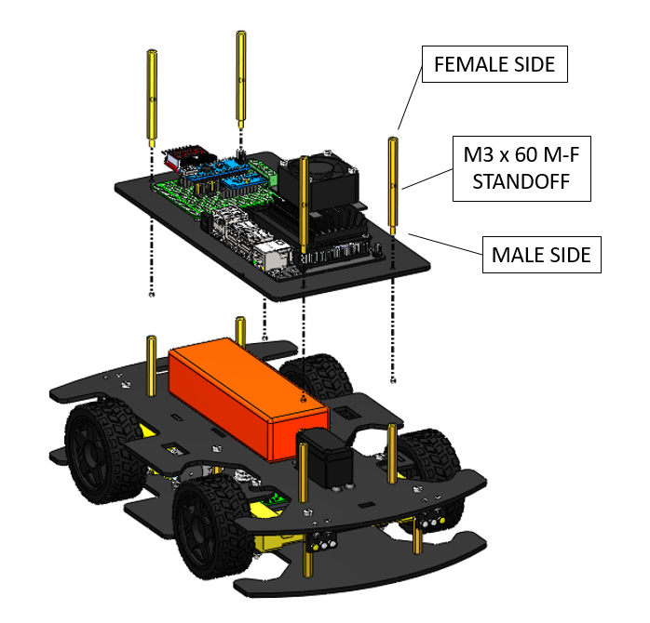

1. Securing the 4th Platform with bolts onto the 3rd Platform standoffs.

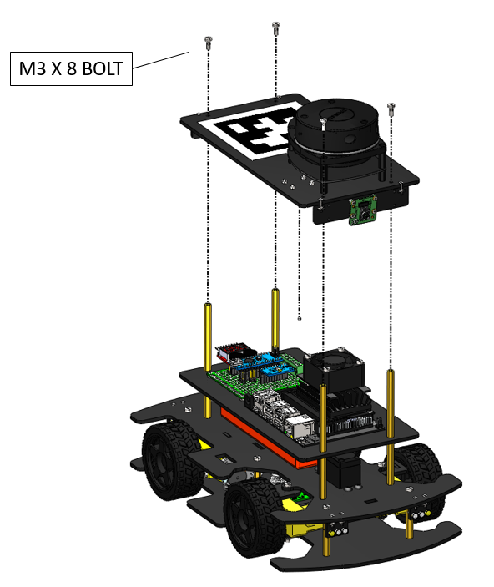

***Hint:*** *Congratulations! Your Nigel is ready for a test drive. Just flash the firmware and take it for a spin!*

# **3. Modularity and Reconfigurability**

AutoDRIVE Ecosystem fosters mechatronics design principles at two levels of design reconﬁgurability, thereby promoting hardware-software co-design.

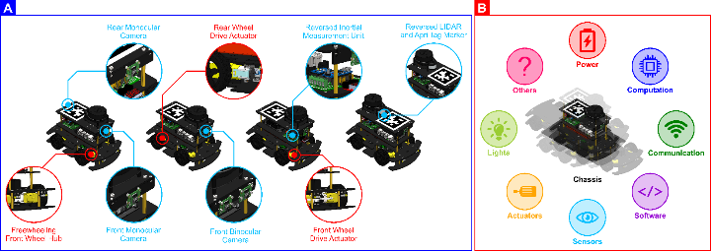

**[A] Primitive Reconﬁgurability:** Nigel is modular enough to support out-of-the-box hardware reconﬁgurability in terms of adding, removing or replacing selective components and sub-assemblies of the vehicle for perception (encoders, IPS, IMU, cameras, LIDAR, etc.), computation (high/low-level), communication (wired/wireless), actuation (Ackermann/skid-steered, front/rear/all-wheel drive), illumination (head/tail-lights, turn/reverse indicators) and power (battery, power electronics) in addition to ﬂexibly updating the vehicle ﬁrmware and/or autonomous driving software stack (ADSS) to better suit target application(s).

**[B] Advanced Reconﬁgurability:** The completely open-hardware, open-software architecture of AutoDRIVE Ecosystem allows complete modiﬁcation of vehicle chassis parameters (different form factors and component mounting proﬁles), powertrain conﬁguration (variable driving performance), as well as ﬁrmware and ADSS architecture (software ﬂexibility), and also provides an opportunity for introducing new features and functionalities to the ecosystem.

# **4. Supplemental Material**



AutoDRIVE Ecosystem is completely open-source, with all the hardware and software source files available publicly. The following resources will come in handy as you get started with AutoDRIVE:

|  |  |
| --- | --- |
|  | <https://autodrive-ecosystem.github.io> |
|  | <https://www.youtube.com/@AutoDRIVE-Ecosystem> |
|  | <https://github.com/AutoDRIVE-Ecosystem> |
|  | <https://doi.org/10.3390/robotics12030077> |

Particularly, the source files for [mechanical](https://github.com/Tinker-Twins/AutoDRIVE/tree/AutoDRIVE-Testbed/Vehicle/Mechanical), [electrical](https://github.com/Tinker-Twins/AutoDRIVE/tree/AutoDRIVE-Testbed/Vehicle/Electrical) and [software](https://github.com/Tinker-Twins/AutoDRIVE/tree/AutoDRIVE-Testbed/Vehicle/Software) components and sub-systems of the Nigel are available on GitHub. Additionally, you can also find the source files for [AutoDRIVE Testbed](https://github.com/Tinker-Twins/AutoDRIVE/tree/AutoDRIVE-Testbed/Vehicle/Electrical), [AutoDRIVE Simulator](https://github.com/Tinker-Twins/AutoDRIVE/tree/AutoDRIVE-Simulator) and [AutoDRIVE Devkit](https://github.com/Tinker-Twins/AutoDRIVE/tree/AutoDRIVE-Devkit), which together make up the AutoDRIVE Ecosystem.